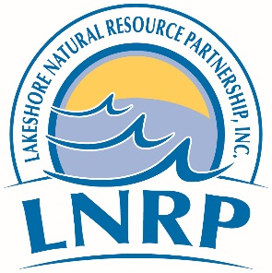

Phragmites Control Program

Landowner Application Form

Landowner(s) Mailing Address City/State/Zip Phone Number Parcel # (located on your property tax bill) Email address (to send project updates)

*By signing below I authorize inventory, treatment and monitoring on my property for the purpose of Phragmites control starting from the date of my signature for the duration of the grant funded period. Annual notifications will be provided to the landowner. Landowners who wish to revoke permission must do so in writing to Glacierland RC&D, PO Box 11203, Green Bay, WI 54307.
The control efforts will involve use of herbicides using spray application. There is no cost to the landowner during the treatment period. I understand this is primarily a Phragmites control program and that educational follow up may be provided through Glacierland RC&D Council, Lakeshore Natural Resource Partnership, partner organizations, or contractors to help maintain or control future infestations. I also understand that as a property owner, I intend to contribute to the success of this effort as feasible by following management recommendations provided to me for effective long-term control.

Signature: Date:

Landowner Site Evaluation (complete to the best of your ability)

- Density of Phragmites: Dense
Scattered
Sparse
None

- Approximate total square feet of Phragmites: _____feet x___ feet

Please return this completed form to:
Stantec Consulting Services, Attn: Melissa Curran, 1165 Scheuring Road,
De Pere, Wisconsin 54115

Questions about the form? Please contact Melissa Curran at 920-841-1072 or Melissa.curran@stantec.com.

